AMD Ryzen 3500x MSI B450m Mortar Max Sapphire RX560 4G iMacPro1,1 Opencore 0.5.8
----------------------------------------------------------------------
HW:

CPU: 6-Core Ryzen 3500x, 3.6 GHz

Graphics: SAPPHIRE Radeon RX 560, 4 GB

Memory Module: P0 CHANNEL A/DIMM 1, 8 GB, DDR4, 2667 MHz, Samsung

Memory Module: P0 CHANNEL B/DIMM 1, 8 GB, DDR4, 2667 MHz, Samsung

PCI Card: Broadcom BCM4360 802.11ac Wireless Network Adapter with pcie adapter card

Serial ATA Device: OCZ-ARC100, 120 GB

Serial ATA Device: SAMSUNG SSD 830 Series, 128 GB

Serial ATA Device: APPLE HDD HTS541010A9E662, 1 TB

MOUSE: APPLE MM2 / LOGITECH M186

USB Device: Lenovo Low Profile USB Keyboard

USB Device: Sirius USB2.0 Camera
---------------------------------------------------------------------------------------------------------------------------
Kexts:

AppleALC, Lilu, VirtualSMC, WhateverGreen, AppleMCEReporterDisabler, AMD-USB-MAP, BT4LEContinuityFixup，Realtekrtl8111，VoodooHDA，AirportBrcmFixup
----------------------------------------------------------------------------------------------------------------------------
Drivers:

HfsPlus, OpenCanopy, OpenRuntime
----------------------------------------------------------------------------------------------------------------------------
ACPI:

SSDT-EC-USBX-AMD.aml
---------------------------------------------------------------------------------------------------------------------------
Working

AIRDROP, HANDOFF, CONTINUITY, FACETIME(with VoodooHDA audio）, IMESSAGE, SLEEP

-----------------------------------------------------------------------------------------------------------------------------
USB MAP

There are two usb controllers on B450m MORTAR MAX named PTXH and XHC0
Actually, there is no necessity to map the type of usb ports, there all works OOB.

CONTROLLER | PORT NAME | PORT TYPE
XHC0 | PRT1 | USB2
XHC0 | PRT2 | USB2
XHC0 | PRT3 | USB2
XHC0 | PRT4 | USB2
XHC0 | PRT5 | USB3
XHC0 | PRT6 | USB3
XHC0 | PRT7 | USB3
XHC0 | PRT8 | USB3
PTXH | POT1 | USB3
PTXH | POT2 | USB3 Type C sw
PTXH | POT3 | USB3
PTXH | POT4 | USB3
PTXH | POT5 | USB2
PTXH | POT6 | USB3 Type C sw
PTXH | POT7 | USB2
PTXH | POT8 | USB2
PTXH | POT9 | USB2
PTXH | PT10 | USB2
PTXH | PT11 | USB2
PTXH | PT12 | USB2
PTXH | PT13 | USB2
PTXH | PT14 | USB2
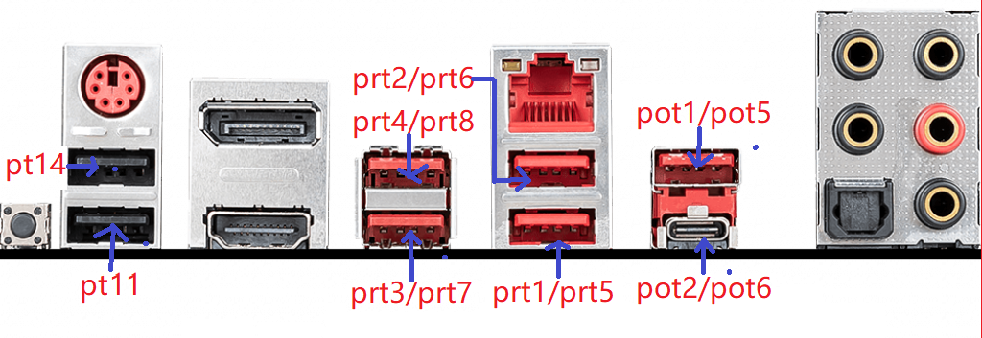
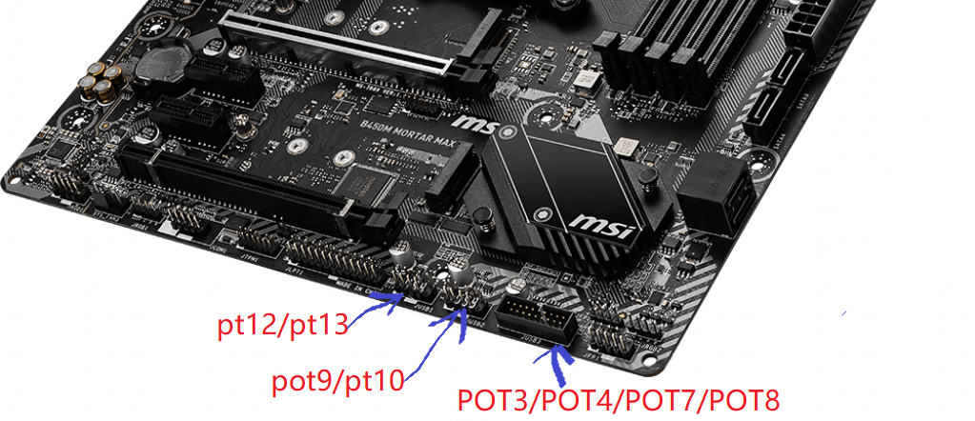

—————————————————————————————————————————-
Known issues fix-up:

1、sleep works with immediate wake-up

a、can be avoid by setup automatic logout：

system preferences->security&privacy->firewall->advanced

b、uncheck "allow bluetooth devices to wake this computer" ( if you use bluetooth mouse)：

system preferences->bluetooth preferences->advanced

2、wake with black screen unless you tap keyboard or mouse twice

fixed with boot arg "darkwake=0" added to config.plist

more information could be found on WhateverGreen git page.

3、system panic on sleep while usb devices connected to XHC0

If there is usb devices connect to XHC0 usb controller, you computer may sleep but with issue:screen turned off, system fans keep spinning, system falls to panic(no wake up, only way is to push power button to restart)

To fix this issue, do the following steps:

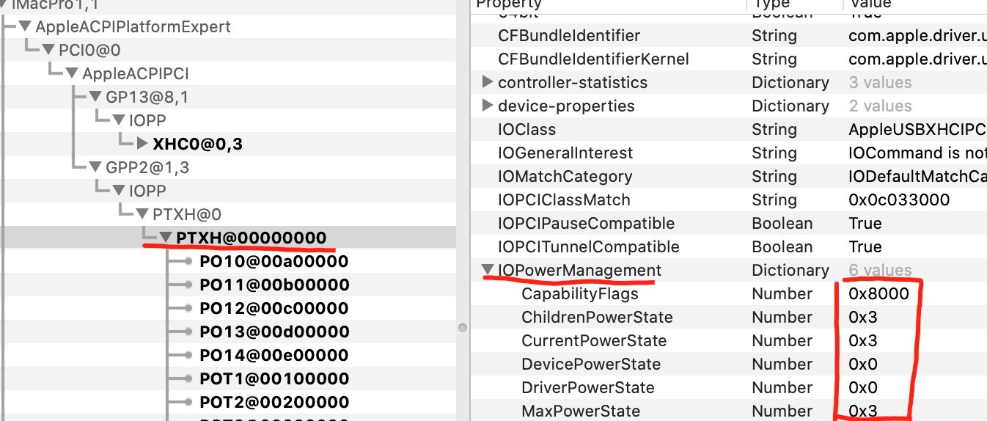
a、check IOPowerManagement of XHC0, compare the differences of the attributes(CapabilityFlags and the other five) to PTXH;

b、if there are differences, match XHC0 to PTXH, by AMD-USB-MAP.kext.
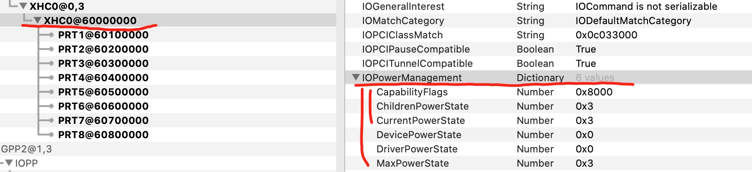
usb controller-XHC0 after matching
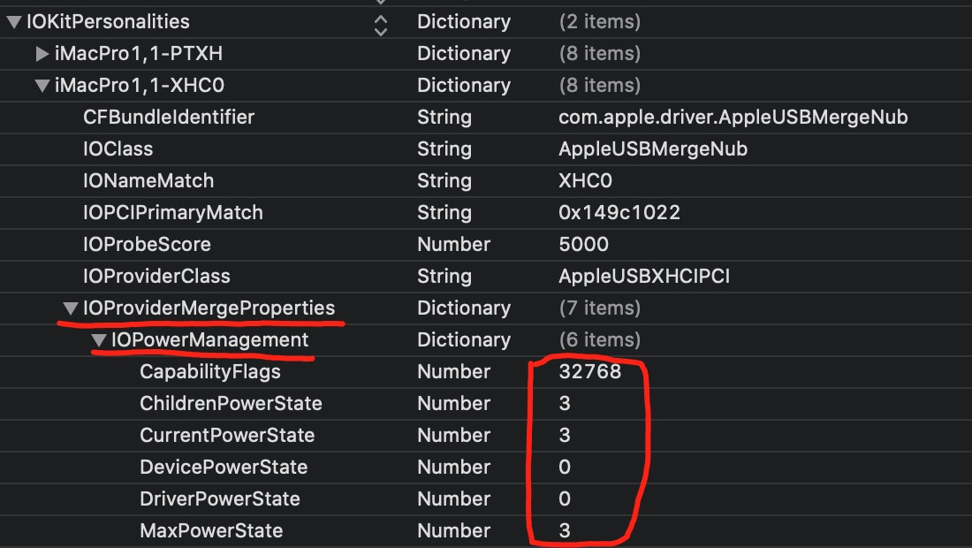
Screen shot of info.plist from AMD-USB-MAP.kext
****0x8000 is hex，so you have to alter it to 32756 in decimal；
****0x8000 suits for B450M MORTAR MAX, you have to find out the one for your motherboard.
-------------------------------------------------------------------------------------------------------------------------------
Many thanks

https://vanilla.amd-osx.com/
https://forum.amd-osx.com/
https://github.com/acidanthera/
https://github.com/dortania
https://github.com/portrayer/Hackintosh-Ryzen-MSI-B450I
https://github.com/aluveitie/RyzenMacPro
https://siriusq.top/Ryzen%20Hackintosh

and all the other people that make hackintosh possible.

